Athlete Vault App

Slide 1: Leveraging Technology To Improve NIL Experience (Video From Miles Jordan or Lily Turner)

Description: NIL Wealth is a game-changing financial management app built specifically for college athletes, helping them take control of their NIL earnings while securing their financial future.

Slide 2: NIL Collective

Slide 3: In 2021, several states and the NCAA passed a law that allowed high school college athletes to profit from their Name, Image, and Likeness (NIL)...
Endorsement Deals – Partnering with brands for sponsorships and promotions.
Merchandise Sales – Selling personalized gear, jerseys, and other branded products.
Social Media Content – Monetizing platforms like Instagram, TikTok, and YouTube through sponsorships and ad revenue.
Problem: Managing NIL deals can be overwhelming, and unfulfilled payments have even led to lawsuits between players and coaches, and 78% of Athletes go broke after retirement
Athlete Vault: puts the power of NIL deals directly in the hands of athletes—no agents, no headaches, just guaranteed payments and long-term financial security. With blockchain-powered smart contracts, athletes get paid on time, in full, and in total compliance with NCAA and state regulations. But we go beyond just payments. Athlete Vault helps athletes grow their wealth with automated savings, Fixed Index Annuities, and AI-driven NIL valuation. Our easy-to-use app lets athletes negotiate deals, connect with brands in real time, and lock in secure payments instantly. No more chasing checks or worrying about bad deals—just full control, smarter earnings, and a future built to last.

But NIL Wealth goes beyond just payments. It helps athletes build long-term financial stability by offering a Fixed Index Annuity (A fixed index annuity (FIA) is a tax-deferred savings account that combines market protection with the potential for growth. FIAs are designed for retirement savers.) A portion of each NIL payment can be automatically set aside and invested, allowing earnings to grow over time with interest. This way, athletes don’t just make money—they make their money work for them.
On top of that, Athlete Vault provides financial education, tax automation, and compliance monitoring, giving athletes everything they need to manage their earnings wisely and prepare for life beyond sports.
Whether an athlete is signing their first deal or managing multiple endorsements, NIL Wealth is the all-in-one financial playbook designed to help them earn, save, and grow their money—effortlessly.

Features:
- Blockchain Smart Contracts – Automates NIL payments, ensures compliance, and keeps secure transaction records.
- Automated Savings & Investments – American Equitsystems help athletes grow earnings with interest.
- AI-Powered NIL Valuation – Estimates market value, suggests sponsorships, and detects fraudulent deals.
Features:
Dual-Slider Interface:
- Athletes have a sliding bar where they set their minimum acceptable and ideal deal value.
- Brands/collectives have their own sliding bar to set their maximum offer and preferred deal value.
Real-Time Market Fit:
- When both parties’ ranges overlap, the system suggests a fair settlement price based on AI-driven market data and Myerson–Satterthwaite principles.
- If no overlap exists, the app provides AI-driven recommendations to adjust expectations based on comparable market trends.
Dynamic Updates:
- As either party moves their slider, NIL Wealth updates the potential deal likelihood and provides real-time feedback on fairness, expected value, and market trends.
Auto-Accept & Instant Smart Contracts:
- Users can set thresholds for automatic deal acceptance if a bid lands within their preferred range, triggering smart contract execution for secure payments.
Market:
- College Athletes – NCAA and NAIA athletes earning NIL income who need financial management, compliance, and investment tools (522,000 Athletes)
- High School Athletes (Future NIL Earners) – Top prospects preparing for NIL opportunities before entering college. ( about 495,000, or roughly 6%, will go on to compete at NCAA schools)
- Brands & Sponsors – Companies seeking streamlined, secure NIL payments and contract management with compliance assurance (SponsorUnited released its 2022-23 NIL Marketing Partnerships Report, analyzing over 2,000 deals in more than 1,000 brands.)
- Universities & Athletic Departments – Schools looking for NIL education, compliance solutions, and financial wellness tools. (252 schools that receive average NIL deals or more)

Revenue Streams
- Subscriptions services to brands who are looking for athletes to endorse their company
  - Serve to connect athletes to companies and facilitate complete transaction
- Charge a transaction fee

- Year 1 ($500K): Athlete & brand subscriptions, 1.5% transaction fees on $2M NIL deals.

Growth Drivers: Scaling user base, new financial products, enterprise partnerships, and expanding market reach.

Whatever is in Red needs to get done before Josh leaves for the Global Trip This Week— Feedback that the professor gave me is we need more visuals, our slide deck needs to have more color.

Market analysis with data (Josh)
Competitor analysis (Naz):https://opendorse.com/ :interesting for potential competitor?
- Porter's 5 forces- visual graph (Naz)
- Perception map (Naz)
Specific financial data (5 year plan excel?- optistic, neutral, pessimistic) (Naz and Josh)
Specific implications plan (software, coding language, partners) (Nikhil) - Features- AI Driven Pricing/ NIL Market Value Predictions, and Fixed Annuity

Perception map
Vertical integration into the future
AI and financial management possibles

Product development mind map
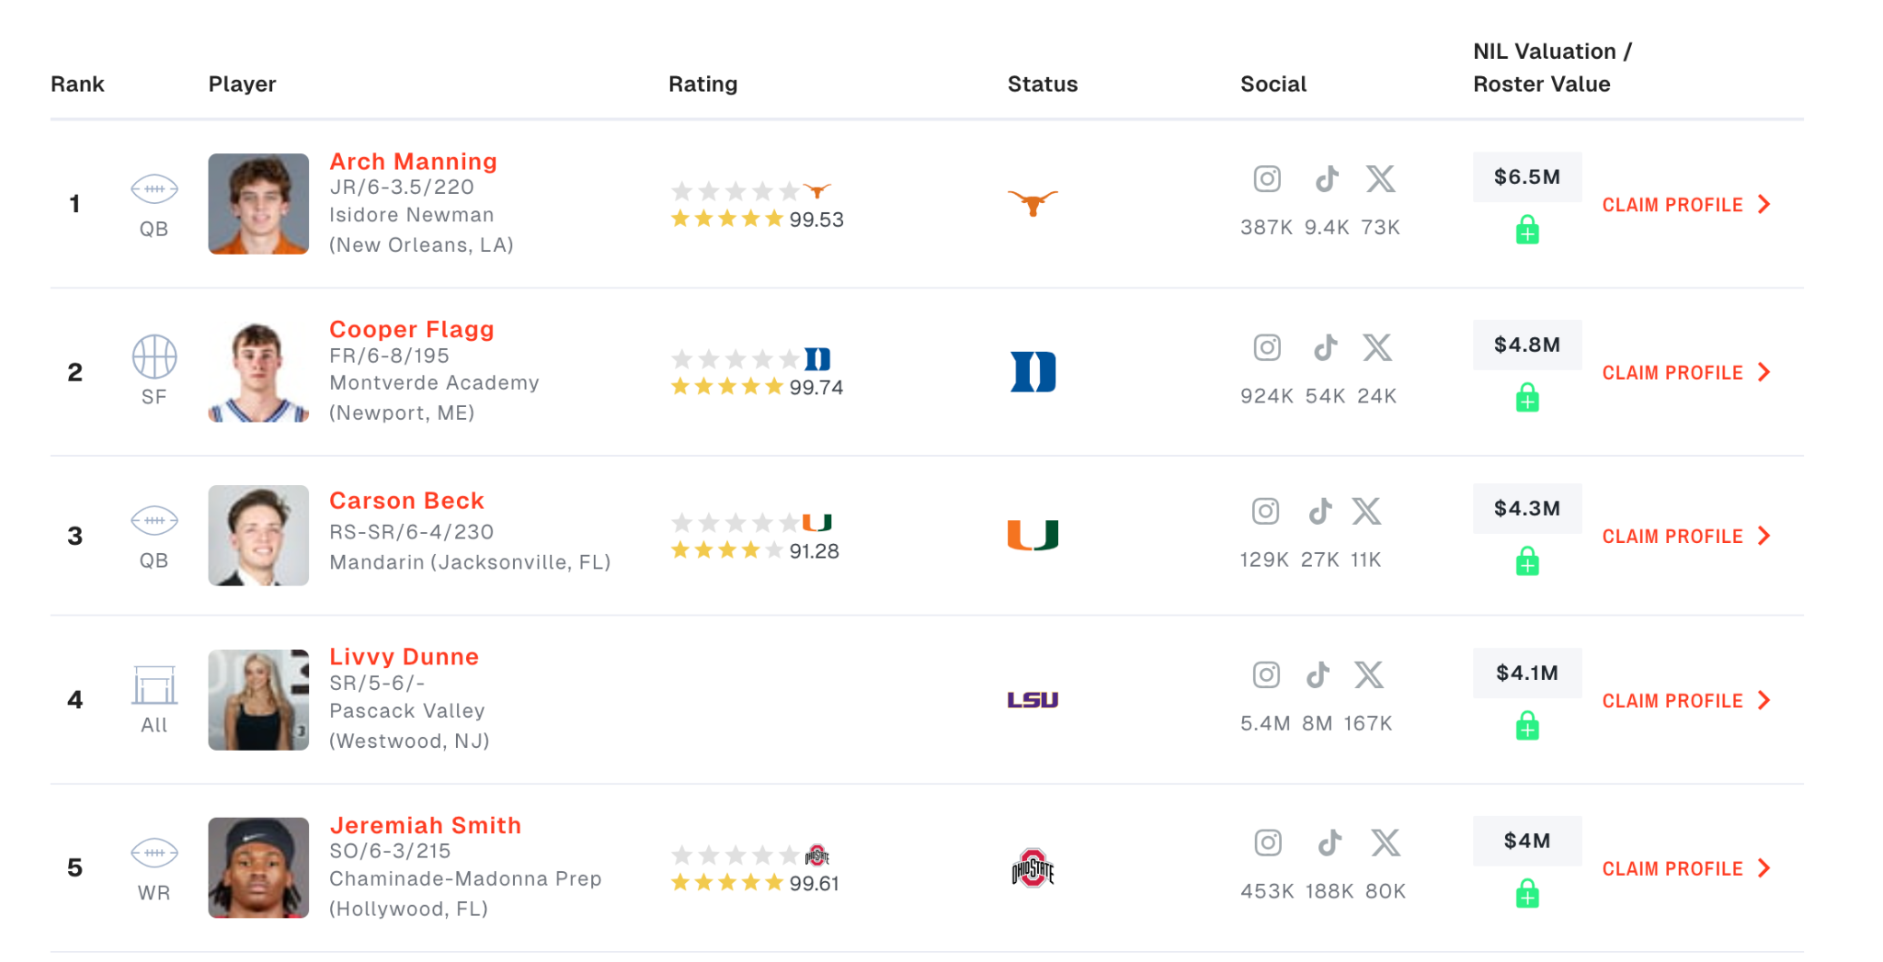
Market Analysis Notes
- More than 450,000 athletes have been involved in NIL deals
- Primary sector is college athletes, male and female, ages 18-24
- Average profits for athletes have a range from $1,000 to $10,000
- Top earners make millions of dollars
- Factors such as skill level, social media presence, family ties, program, etc. can effect an athletes valuation
- First clients
  - Top Earners at (High Profile Schools)
  - Miles Jordan’s clients
  - Connections with influencers to market outward
- Potential filing as LLC in a state like Texas or Florida, where there is no income tax and large NIL market
  - Near schools like Texas A&M, University of Texas or Florida Gators, University of Miami, Florida State, etc.
  - Austin, Texas would be a good hub in a growing city if physical location becomes important
  - Possible expansion rather than initial, since we will not be able to interview people in those states before we present

Strengths | Weaknesses
- AI-driven market recommendations  - Smart contracts for security  - Long-term financial management solutions | - Limited initial resources  - New market entrant
Opportunities | Threats
- Expanding NIL market  - Smaller sports are gaining popularity  - High demand for legal compliance and security | - NIL regulation changes  - Competitor growth and market saturation  - Economic uncertainty
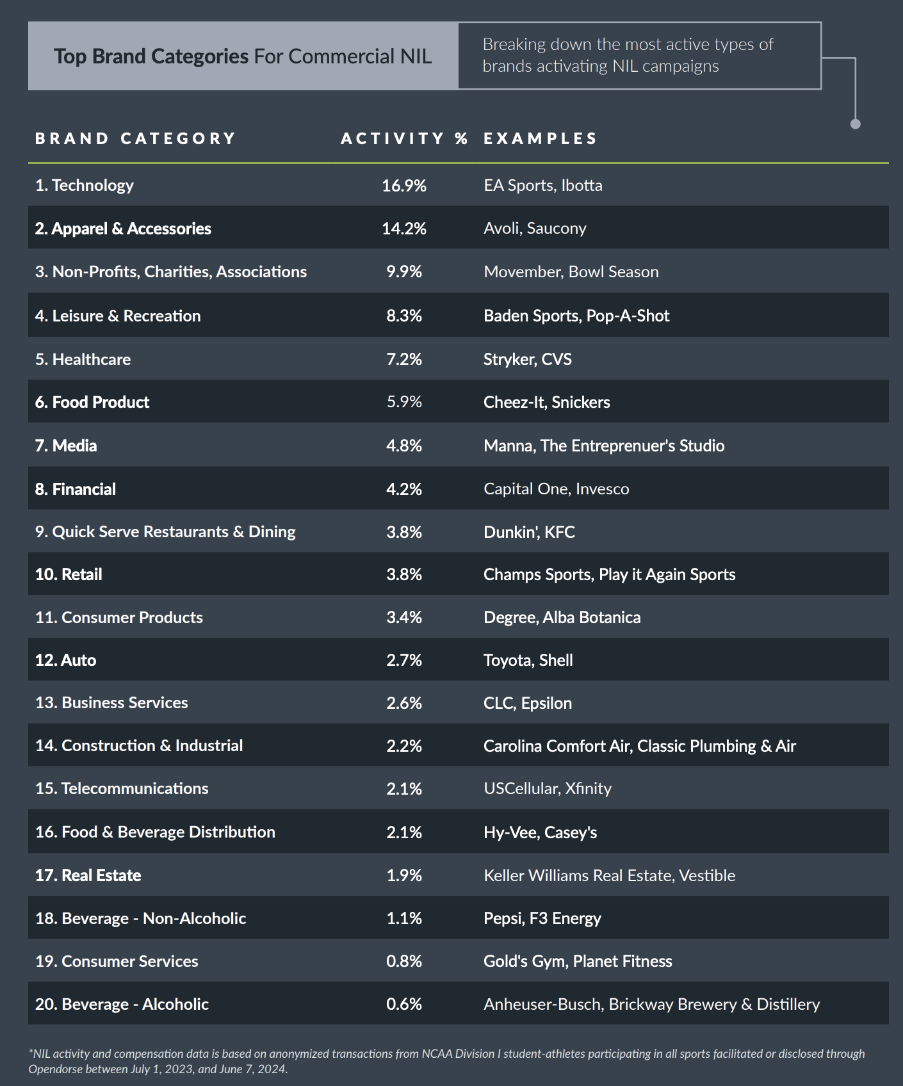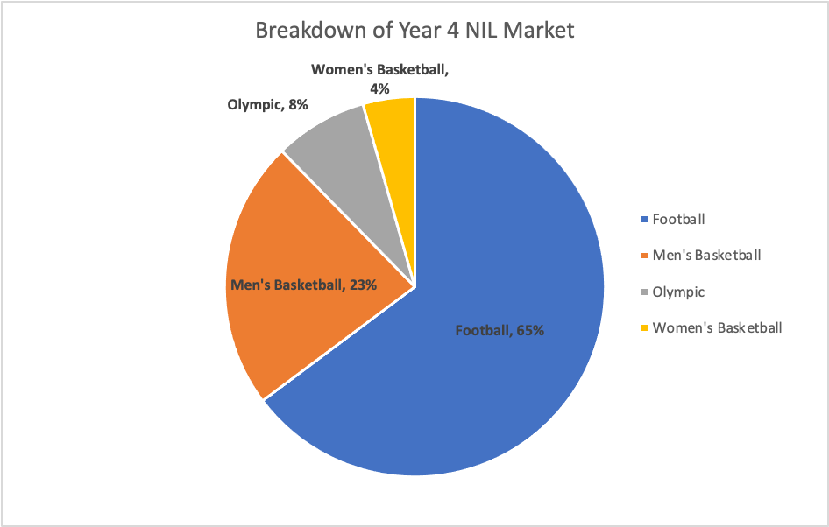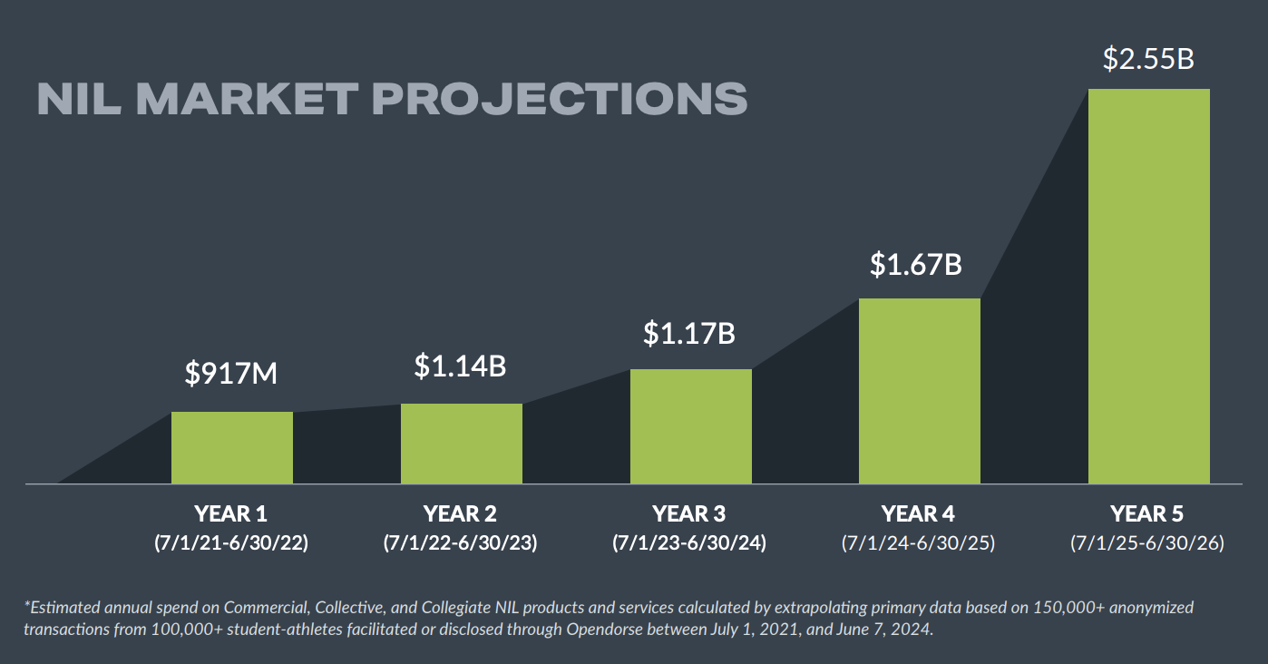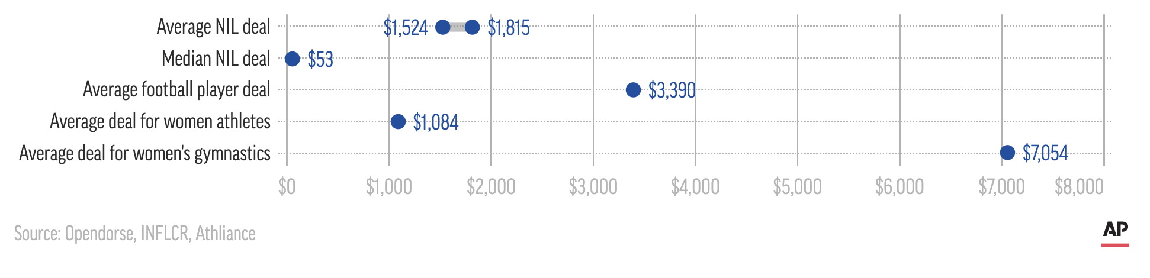
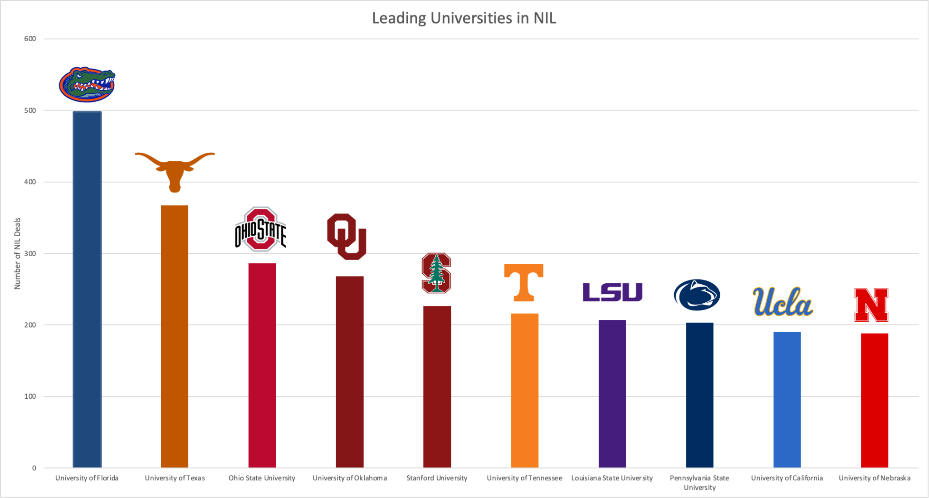

Links to sources:
https://calmatters.org/wp-content/uploads/2024/10/The_Annual_Opendorse_Report_-Version-2.pdf
https://en.as.com/ncaa/who-is-the-highest-paid-college-athlete-nil-endorsement-deal-money-in-ncaa-sports-n-2/
https://www.on3.com/nil/rankings/player/nil-valuations/
https://nittanylionswire.usatoday.com/story/sports/college/nittany-lions/football/2024/07/18/top-10-colleges-with-the-most-nil-deals-for-athletes/78590297007/
https://www.nbcnewyork.com/news/sports/one-year-of-nil-how-much-have-athletes-made/3765040/

